The members:

HARRI SJÖSTRÖM
- Soprano saxophone
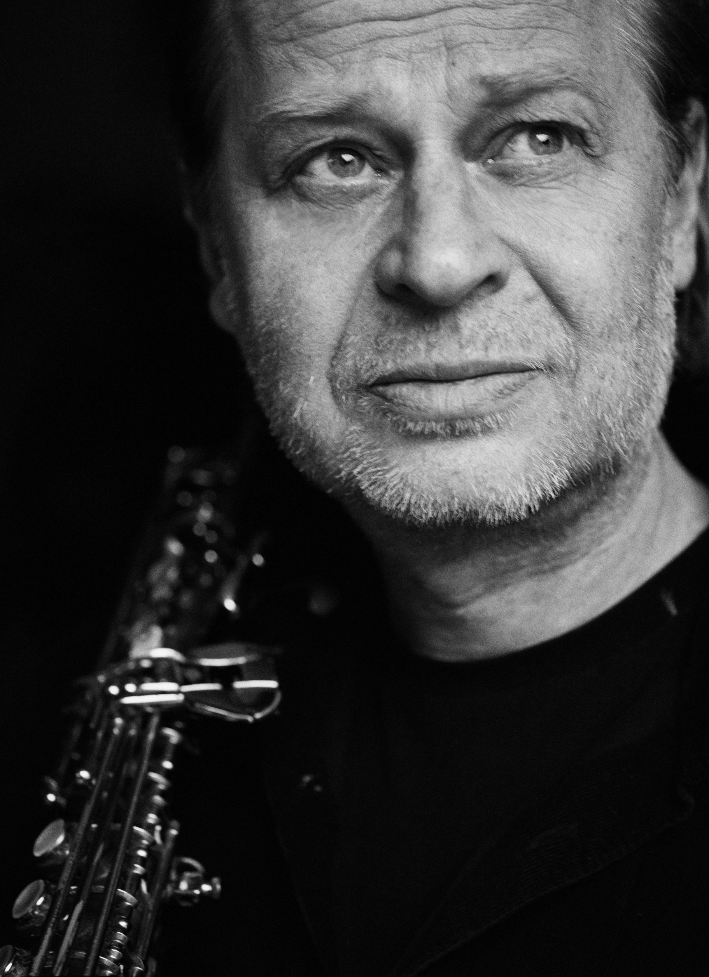

Born 29 February1952 in Turku, Finland.
The joyful, creative and intensive experiences with contemporary music and contemporary improvised music studies, as well as visual art studies captivated Harri so much that he has worked intensively ever since with contemporary music and contemporary improvised music and in mixed media projects including film, photography, visual arts, theater and dance.
Harri Sjöström had founded several projects such as the international Quintet Moderne and, Harri Sjöström Quartet, Three Meters Dog, Wait, Motström, Up And Out, ECIO (European Contemporary Improvisation Orchestra); co-founded the The Player Is trio with Teppo Hauta-aho and Philipp Wachsmann.
He has collaborated with a large number of leading musicians in the international contemporary music scene since the late 70s, such as Derek Bailey, Cecil Taylor, Paul Lovens, Tony Oxley, Barry Guy, and John Russell; and performed at numerous international jazz and contemporary music festivals. Occasionally he performs solo and is involved in making film music.

www.harrisjostrom.com

ADAM PULTZ MELBYE
- Double bass
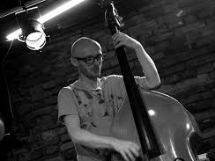

Born in Ribe, Denmark in 1981. Currently living in Berlin.
Adam has achieved recognition as one of the most active bass players on the Danish scene for improvised music, forming a number of co-led bands and working in numerous ad-hoc constellations with musicians from all over the world. His continuous studies to investigate and expand the vocabulary of the double bass, has made him one of the very few Danish bass players to perform improvised solo concerts.
Melbye has collaborated with Peter Brötzmann, Rudi Mahall, Henrik Walsdorff, Sofia Jernberg, Axel Dörner, Johannes and Conny Bauer, Mark Sanders, Tobias Delius, Fred Lonberg-Holm, Lotte Anker, London Improviser’s Orchestra, Pierre Dørges New Jungle Orchestra a.o.
Working bands: Adam Pultz Melbye’s Gullet (solo), Adam Pultz Melbye’s Minimum Probability Ensemble, Angel, The Mighty Mouse, St. Andby, Walsdorff/Melbye/Tom. Sideman in Maria Faust Group, Markus Pesonen Hendectet and Jesper Zeuthen Trio and PLUS.
Member of the record label and collective Barefoot Records.

www.adampultz.com

DAG MAGNUS NARVESEN
- Drums
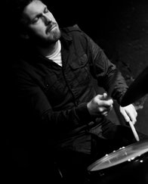

Dag Magnus Narvesen, born the 3rd of January 1983 in Stavanger, Norway.
He’s a drummer, percussionist and composer who mainly works within the field of improvised music and progressive jazz music. Although he graduated from his jazz studies from the jazz departments of the University of Stavanger (UiS) and the University of Science in Trondheim (NTNU) in 2008, he has been professionally active since 2005. He is among other bands active in the contemporary and improvisational music of the Stavanger-based Kitchen Orchestra, where he also was a board member for 7 years, 3 of them as board director; the band Gunhild Seim & Time Jungle and his own octet DAMANA, where he also composes all the music.

Dag Magnus Narvesen's sound can be described as very energetic with lots of different textures developing simultaneously. There is a very strong melodic quality in the way he approaches the drums and his playing is also very influenced by what he calls elliptic grooves, - sequences of rhythmic elements which are resembling grooves and creating a forward motion without playing "in time". He is a very versatile and creative drummer who always is very much present in the moment.

Dag Magnus Narvesen has throughout the years collaborated with many profiled musicians, among them: Evan Parker, Andrew D'angelo, Marilyn Crispell, Alexander von Schlippenbach, Keith Tippet, Steve Beresford, Didrik Ingvaldsen, Johannes Bauer, Fredrik Ljungkvist and many more.
www.dagmagnus.com

EMILIO GORDOA RODRIGUEZ
- Vibraphone
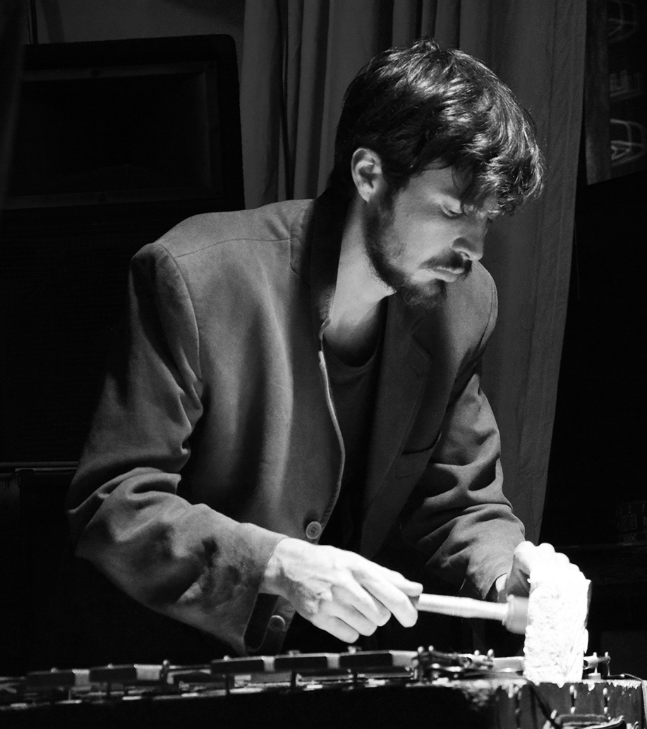
Born in Mexico City in 1987, lives and works in Berlin and Mexico City.

Mexican musician, composer and vibraphonist, he is involved in numerous projects, the highlights of which are those related to experimental music, noise, free jazz, improvisation and contemporary music. Some of his recent projects are: SOEL (electro acoustic quartet), Mano Morta, LEEM, Para.keEts (trio with Ute Wassermann and Richart Scott) and MOvE.

He is redefining the vibraphone as a source, treating it with preparations and extended techniques, and is a busy composer as well, writing graphic scores for a variety of ensembles, large and small, for theatre, documentary films and audiovisual.

Emilio has worked with artist such as John Russell, Tristan Honsinger, German Bringas, Misha Marks, Tobi Delius, Liz Allbee, Remi Alvarez, Chris Cogburn, Clayton Thomas, Klaus Kürvers, Tony Buck, Alexander Bruck, Juan García, Bonnie Jones, Harri Sjöström, Frank Paul Schubert, Daniel Ott and Ute Wassermann. He has performed in several venues and festivals around Europe as the Copenhagen Jazz Festival in 2014, Klangkunstprojekte of Leipzig, Art Sound Festival Berlin, CSW (Contemporary Art Museum of Warsaw), and in Vortex London, at the MOPOMOSO series of John Russell.
www.emiliogordoa.tumblr.com

ACHIM KAUFMANN
-Piano and Synthesizer
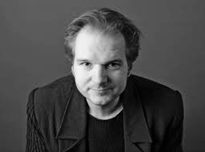

Achim Kaufmann was born into a musical family in Aachen, Germany, in 1962. He studied music at the Conservatory in Cologne and also took classes with creative masters such as Dave Holland, Steve Coleman, Muhal Richard Abrams, George Lewis, and Steve Lacy.
Achim mixed techniques are used to create a fluctuating world of sounds and gestures. Resonance and reverberation, space and density play an important role in both his solo and ensemble work.

Since his move to Berlin, he got involved in various new projects, such as the trio grünen with Robert Landfermann and Christian Lillinger, Oni Kramler (with Matthias Schubert, Antonio Borghini, and various guests), and a trio with cellist Okkyung Lee and trumpeter Axel Dörner.
In 2013, the sextet SKEIN (Kaufmann/Gratkowski/de Joode plus Richard Barrett, Okkyung Lee, and Tony Buck) had its premiere at the dOeK festival in Amsterdam and subsequently recorded for SWR radio.

In addition, Achim has played and/or recorded with Han Bennink, Mark Dresser, George Lewis, Steve Swallow, Tobias Delius, Lehn, Ab Baars, Paul Lovens, Dylan van der Schyff, Peggy Lee, Chris Speed, Tomász Stanko, Bill Elgart, Paul Lytton, Harri Sjöström, Andrea Parkins, Harris Eisenstadt, Ingrid Laubrock, Tristan Honsinger, Thomas Heberer, Urs Leimgruber, Roger Turner, Fay Victor, Fred Lonberg-Holm, John Hollenbeck, Bob Brookmeyer, Simon Nabatov, Lê Quan Ninh, Gerry Hemingway, John Hébert, Al Foster, Adam Nussbaum, and many more.

www.achimkaufmann.com

