The Members

HARRI SJÖSTRÖM
Soprano & sopranino saxophone
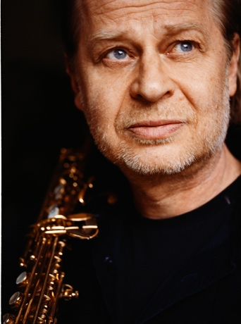

Harri Sjöström, born on 29 February 1952 in Turku, Finland, found his voice in music on the soprano and sopranino saxophone. His music and fine art studies in San Francisco in the 1970s led him directly to workshops by John Cage, Vinko Globokar, George Russell, Bill Dixon and to his saxophone teachers Leo Wright and Steve Lacy.
Ever since he worked extensively within the fields of contemporary improvised music and mixed media projects. Back to Europe 1978 he started to work with Derek Bailey, Paul Lovens, John Russell, Paul Rutherford, Alexander von Schlippenbach a.o.

Between 1990 and 2016 an extensive collaboration with the pianist and composer Cecil Taylor developed, including five live recordings with small ensembles and recordings with larger C.T. orchestras. Of particular note is the Cecil Taylor Quintet with C.T., Teppo Hauta-aho, Tristan
Honsinger, Paul Lovens.

Energetic and with an appetite for risk he founded and co-founded many ensembles with highly interesting instrumental line-ups including such as Quintet Moderne, European Composers Improvisors Orchestra (ECIO), Sestetto Internazionale, MOVE quintet, Up And Out, City Of Pyramids, The Player Is, Motström a.o.

Cooperation with Sergio Armaroli, Matthias Bauer, Alison Blunt, Tony Buck, Lawrence Casserley, Andrea Centazzo, Michel Doneda, Emilio Gordoa, Frank Gratkowski, Teppo Hauta-aho, Steve Heather, Tristan Honsinger, DJ – Illvibe, Wilbert de Joode, Achim Kaufmann, Kalle Kalima, Veli Kujala, Okkyung Lee, Adam Pultz Melbye, Gianni Mimmo, Jeffrey Morgan, Libero Mureddu, Dag Magnus Narvesen, Evan Parker, Guilherme Rodrigues, Ignaz Schick, Jean Michel van Schouwburg, Giancarlo Schiaffini, Philipp Wachsmann a.o.
www.harrisjostrom.com

ADAM PULTZ MELBYE
Double bass
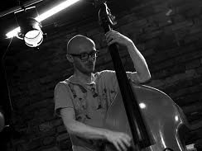
Adam is a double bass player, composer, sonic researcher and audio programmer. He holds a soloist degree form the academy of music in Copenhagen and is currently undertaking practice-led PhD research at Queen’s University’s Sonic Arts Research Centre (SARC) in Belfast, Northern Ireland. He has toured Europe, the US, Japan, and Australia and appears on around 50 albums, three of these being solo releases. He has composed and performed music for film, theatre, dance, and has created 3D – printed sculptures with the project Every Vessel. Adam is currently exploring electro-acoustic double bass performance systems, one of which, the FAAB, won Best Music Prize at the NIME conference in 2020. His work has been performed at festivals such as Wien Modern, Copenhagen Jazz Festival, and Blurred Edges (Hamburg), and the National Museum of Art (Denmark).
His writing has appeared in international peer-reviewed academic journals and conferences.

Apart from an active solo practice, Melbye has collaborated with Julia Reidy, Lotte Anker, Evan Parker, Ingrid Schmoliner, Pat Thomas, John Russell, Peter Brötzmann a.o.
www.adampultz.com

DAG MAGNUS NARVESEN
Drums
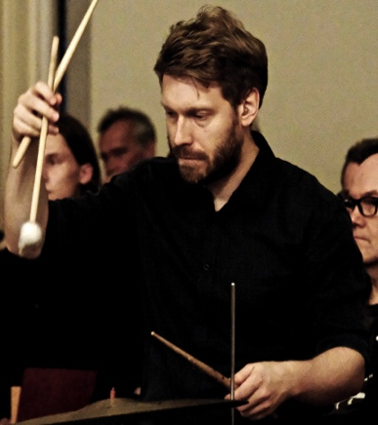

Dag Magnus Narvesen, born the 3rd of January 1983 in Stavanger, Norway.
He’s a drummer, percussionist and composer who mainly works within the field of improvised music and progressive jazz music. Although he graduated from his jazz studies from the jazz departments of the University of Stavanger (UiS) and the University of Science in Trondheim (NTNU) in 2008, he has been professionally active since 2005. He is among other bands active in the contemporary and improvisational music of the Stavanger-based Kitchen Orchestra, where he also was a board member for 7 years, 3 of them as board director; the band Gunhild Seim & Time Jungle and his own octet DAMANA, where he also composes all the music.

Dag Magnus Narvesen's sound can be described as very energetic with lots of different textures developing simultaneously. There is a very strong melodic quality in the way he approaches the drums and his playing is also very influenced by what he calls elliptic grooves, - sequences of rhythmic elements which are resembling grooves and creating a forward motion without playing "in time". He is a very versatile and creative drummer who always is very much present in the moment.

Dag Magnus Narvesen has throughout the years collaborated with many profiled musicians, among them: Evan Parker, Andrew D'angelo, Marilyn Crispell, Alexander von Schlippenbach, Keith Tippet, Steve Beresford, Didrik Ingvaldsen, Johannes Bauer, Fredrik Ljungkvist and many more.
www.dagmagnus.com

EMILIO GORDOA
Vibraphone & percussion
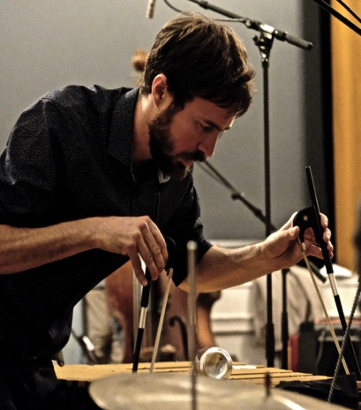
Born in Mexico City in 1987, lives and works in Berlin and Mexico City.

Mexican musician, composer and vibraphonist, he is involved in numerous projects, the highlights of which are those related to experimental music, noise, free jazz, improvisation and contemporary music. Some of his recent projects are: SOEL (electro acoustic quartet), Mano Morta, LEEM, Para.keEts (trio with Ute Wassermann and Richart Scott) and MOvE.

He is redefining the vibraphone as a source, treating it with preparations and extended techniques, and is a busy composer as well, writing graphic scores for a variety of ensembles, large and small, for theatre, documentary films and audio-visuals.

Emilio has worked with artist such as John Russell, Tristan Honsinger, German Bringas, Misha Marks, Tobi Delius, Liz Allbee, Remi Alvarez, Chris Cogburn, Clayton Thomas, Klaus Kürvers, Tony Buck, Alexander Bruck, Juan García, Bonnie Jones, Harri Sjöström, Frank Paul Schubert, Daniel Ott and Ute Wassermann. He has performed in several venues and festivals around Europe as the Copenhagen Jazz Festival in 2014, Klangkunstprojekte of Leipzig, Art Sound Festival Berlin, CSW (Contemporary Art Museum of Warsaw), and in Vortex London, at the MOPOMOSO series of John Russell.
www.emiliogordoa.tumblr.com

ACHIM KAUFMANN
Piano & Synthesizer
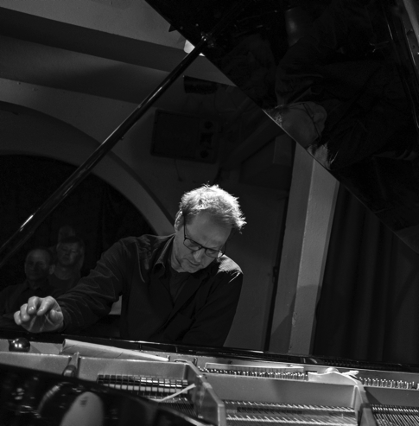

Achim Kaufmann is a pianist and composer currently based in Berlin who uses mixed techniques to create a fluctuating world of sounds and gestures.
He studied music at the Conservatory in Cologne and also took classes with creative masters such as Dave Holland, Steve Coleman, Muhal Richard Abrams, George Lewis, and Steve Lacy.
He has lived in Cologne, Paris, and particularly in Amsterdam where he was based from 1996 to 2009, becoming part of the city’s internationally renowned improvised music scene.
In 1998, he founded a quartet with reedist Michael Moore and percussionist John Hollenbeck. Since 2002, he has been touring internationally with Kaufmann/Gratkowski/de Joode, an improvising trio which has released five CDs to much critical acclaim.
Other working groups include grünen with Robert Landfermann and Christian Lillinger, SKEIN as well as duos with Michael Moore and percussionist Yorgos Dimitriadis.
He and the poet and visual artist GDR Guenther have collaborated on a number of projects and founded the publishing platform for music and poetry, Trokaan.
In their most recent Trokaan Project, they brought together an illustrious group of improvisors (Liz Allbee, Frank Gratkowski, Kazu Uchihashi, Richard Barrett, Wilbert de Joode, Gerry Hemingway) who have integrated aspects of chamber music, poetry, improvisational dialogue, electro-acoustic textures, full-blown free ensemble playing, and the occasional groove on their cd “13 Asperities” released in 2020.
Kaufmann has also performed and/or recorded with Han Bennink, George Lewis, Mark Dresser, Paul Lovens, Tony Buck, Fay Victor, Ingrid Laubrock, Tom Rainey, Shelley Hirsch, Paul Rutherford, Steve Swallow, Jim Black, Thomas Lehn, Okkyung Lee, Axel Dörner, and many others.
He was awarded the German SWR Jazz Award in 2001, and the prestigious Albert Mangelsdorff award in 2015.

